SRS Document

Project Details

Name of App-Goal net zero

Group members-

* Ashwin Gupta
* Priya Singh
* Mouli Bhatnagar
* Rashi Agarwal

Purpose

This document's goal is to outline the software specifications for a website that tracks and estimates the CO2 emissions linked to transportation (mobilities). This software attempts to promote eco-friendly transportation and increase environmental awareness. This system is designed to help individuals and organizations track, manage, and reduce their carbon footprints.

Scope

This application will allow users to estimate the CO2 emissions generated by their transportation choices, distance, log trips. The system aims to promote environmentally responsible behavior. This website allows users to monitor carbon emissions happening by their choices of mobilities.

Product Features

The website will include features such as user registration, mobility selection, distance calculator, CO2 emissions calculation, trip logging.

Assumption: Users have internet access.

Dependency: Availability of external mobility data sources and emissions calculation APIs.

Non-functional requirements

Performance Requirements

* The system should respond to user interactions within seconds to provide a seamless user experience.
* The application should handle concurrent user requests gracefully, with the ability to scale horizontally to accommodate increased user traffic.
* The system should undergo load testing to ensure it can handle a significant number of concurrent users without degrading performance.

Security Requirements

* User data, including personal information and trip history, must be stored securely and comply with relevant data privacy regulations.
* The authentication mechanism must be robust and ensure that only authorized users have access to sensitive features.
* Admin panel access should be restricted to authorized administrators.

Reliability and usability

* Regular backups of user data should be performed, and a disaster recovery plan should be in place to minimize data loss in case of system failures.
* The user interface (UI) should follow platform-specific design to provide an intuitive and user-friendly experience.

Legal and Compliance Requirements

* The CO2 emissions calculations should align with established environmental standards and guidelines.
* The application must comply with data privacy regulations and clearly communicate its data usage and privacy policies to users.
* Ensure compliance with any third-party software licenses used in the application.

Functional requirements

Registration and authentication

* Users should be able to create an account using an email address or social media profiles.
* User registration should require a username and password.
* Registered users should be able to log in securely with their credentials.
* Passwords should be stored securely, preferably using encryption.

Mobility Selection

* Users should be able to select from a range of transportation options.
* For each mode of transportation, users should be able to specify additional details such as vehicle type and fuel type.

Calculation

* The application should calculate CO2 emissions based on user-entered mobility data and factors such as distance, vehicle type, and fuel efficiency.
* Emissions data should be presented in a clear and understandable format.

Admin panel

* Admin users should have the ability to manage user accounts, including creating, updating, and disabling accounts.
* Admin users should be able to monitor system performance, including user activity and system health.

ER diagram

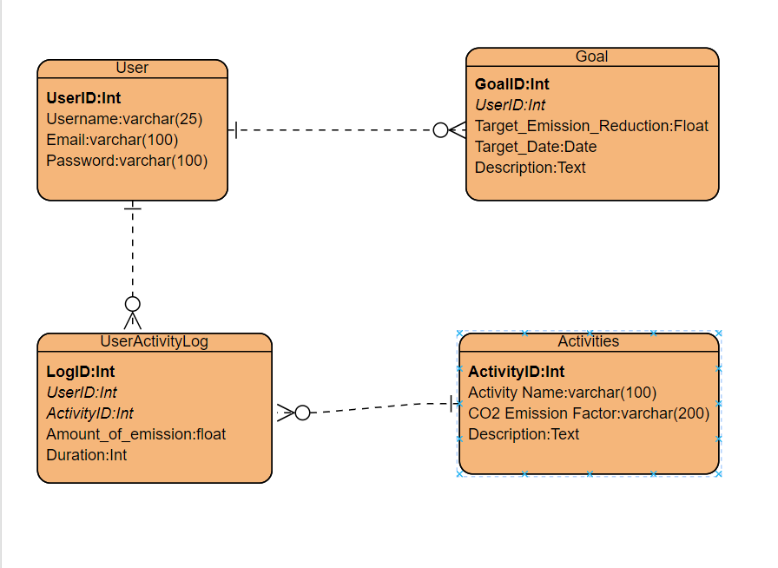

Sequence Diagram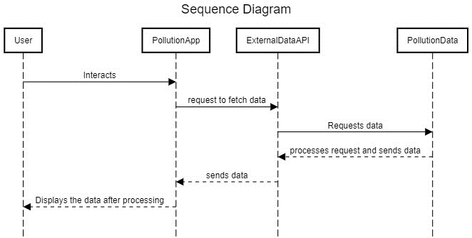

Use Case Diagram

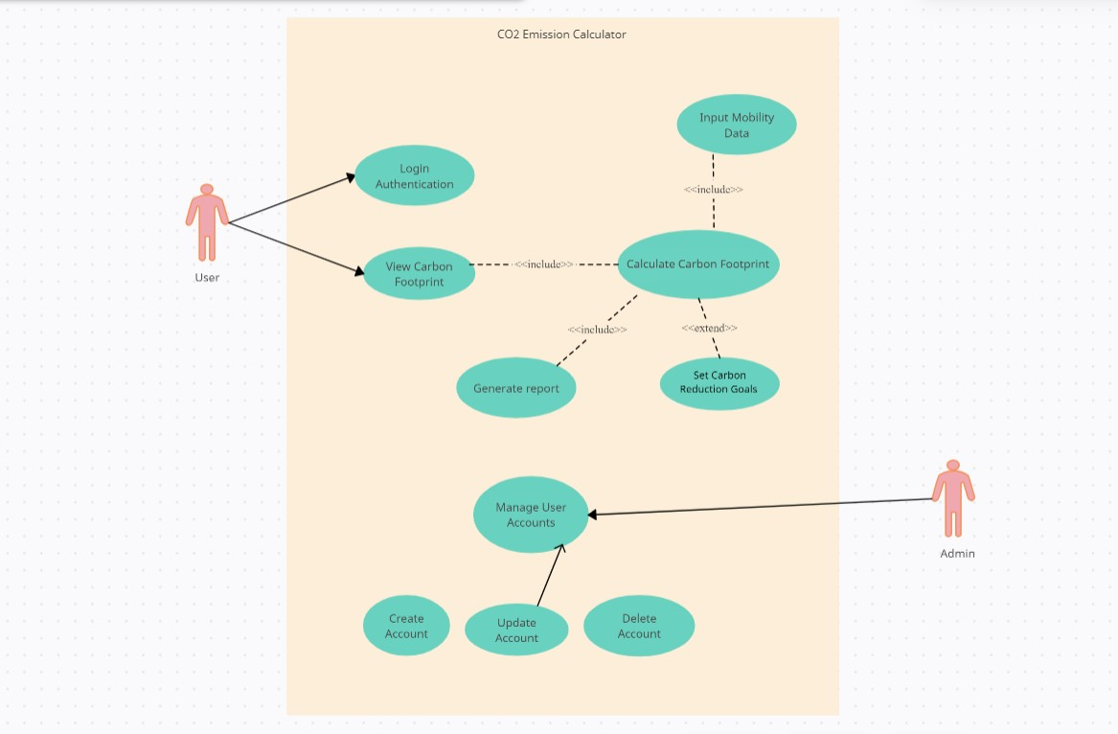

Hardware and Software Details

Software

* .Net
* C#
* React
* PostgreSQL
* JavaScript
* Visual Studio
* Type Script

Hardware

* Any PC that can run these programs